**EXTRACT FROM MINUTES OF ORDINARY MEETING – 20 APRIL 2016**

**STAFF REPORT**

**3 STAGE 1 - NORTHERN GATEWAY TRANSPORT HUB (S1045/01)**

**Report Author: Sue Calvin Team Leader Landuse Planning**

**Authorised: Richard Pamplin Senior Leader Planning and Environmental Services**

**SUMMARY**

Stage 1 of the Northern Gateway Transport Hub seeks to establish a transport depot for Pearsons Transport at Cundletown. The draft Planning Proposal and the draft Local Area Plan were exhibited from 4 March to 5 April 2016. During the exhibition period four submissions were received. Three submissions supported the proposal and one submission from the applicant requested changes to the draft Local Area Plan. Each of the submissions have been considered and it is recommended that both the draft Planning Proposal and the draft Local Area Plan should proceed.

**RECOMMENDATION**

(i) That the Planning Proposal for Stage 1 of the Northern Gateway Transport Hub (Attachment (i)) be forwarded to the NSW Department of Planning and Environment to make the plan.

(ii) That the Local Area Plan (Attachment (ii)) be included in the *Greater Taree Development Control Plan 2010*.

**BACKGROUND**

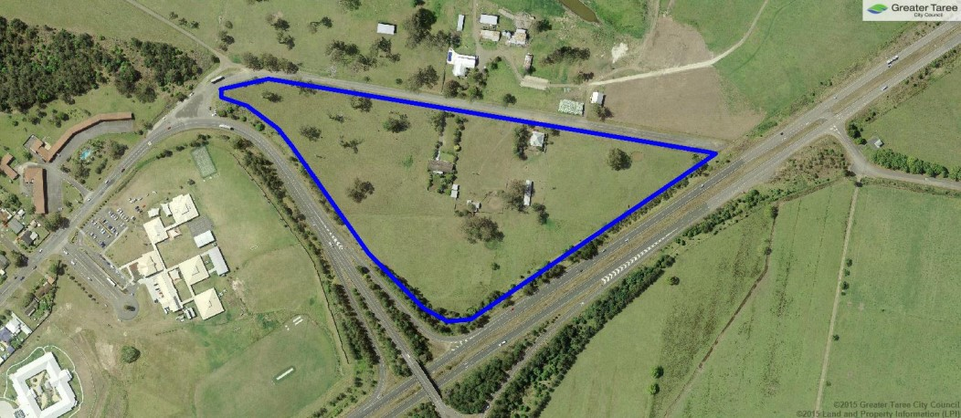Stage 1 of the Northern Gateway Transport Hub (see figure 1) has an area of 7ha and is bordered by Princes Street to the south, the Pacific Highway to the east and Emerton Close to the north‐west. An application for stage 2 of the hub (approx. 67ha) is expected later this year.

**Figure 1** - Stage 1 of the Northern Gateway Transport Hub

A Planning Proposal for stage 1 of the Northern Gateway Transport Hub was lodged by Coastplan (on behalf of Pearsons Transport) to amend the *Greater Taree Local Environmental Plan 2010* (LEP) by rezoning Lot 17 DP 856622 and Lots 44 and 46 DP 1191326 from RU1 Primary Production and RE1 Public Recreation to IN1 General Industrial to enable the establishment of a truck transport depot (see Attachment (i)).

A draft Local Area Plan to be included in the *Greater Taree Development Control Plan 2010* was developed to address site specific development requirements including landscaping, acoustic measures, flooding and traffic (see Attachment (ii)).

Consultation on the draft Planning Proposal and draft Local Area Plan was undertaken from 4 March to 5 April 2016. The Planning Proposal is in the final stages of assessment as shown below.

|  |  |  |  |  |  |  |
| --- | --- | --- | --- | --- | --- | --- |
| **Application lodged**  **(Sept 2014)** | **Council report**  **(Feb 2015)** | **Gateway Determination**  **(Aug 2015)** | **Exhibit planning proposal**  **(Mar-April 2016)** | **Consider submissions. Report to Council**  **(April 2016)** | **Seek Parliamentary Counsel opinion**  **(Apr-June 2016)** | **Minister approve rezoning**  **(July 2016)** |

**DISCUSSION**

**Gateway Determination**

A Gateway Determination was issued by the NSW Department of Planning and Environment on 27 August 2015 (Attachment (i)). The Determination required:

* *An assessment of contamination to ensure consistency with State Environmental Planning Policy (SEPP) 55 – Remediation of Land.*

Response - A report was undertaken by Regional Geotechnical Solutions which addressed the requirements of the SEPP and found acceptable levels of contamination on the site for the intended use.

* *Consideration of the proposals consistency with the SEPP (Exempt and Complying Codes) 2008.*

Response - Additional information was provided in section 4.2.3(g) of the draft planning proposal

* *Consultation with Roads and Maritime Services (RMS) regarding traffic and access to the Pacific Highway*.

Response - RMS raised concerns about the impact of access into Emerton Close from Princes Street. They recommended a roundabout be provided at this intersection to address potential queuing issues. This solution was included in the draft planning proposal and the draft Local Area Plan.

* *Consultation with the Civil Aviation Safety Authority (CASA).*

Response - A late response from CASA advised that relevant airport guidelines need to be considered in the future development of this site (eg. lighting). The Local Area Plan has been amended to ensure airport requirements are considered at the development application stage.

* *Community consultation for 28 days (outlined below)*
* *Completion of the planning proposal by 3 September 2016.*

**Submissions**

Four submissions were received during the 28 day public exhibition period. Copies of these submissions are provided in Attachment (iii). Three submissions provided support for the Planning Proposal. The fourth submission was from the applicant on behalf of Pearsons Transport requesting an amendment to the draft Local Area Plan to remove the need to fund the entire roundabout.

In this regard, it should be noted that the RMS were concerned that the traffic solutions provided by the applicant had not considered increased development in Cundletown and that the most acceptable traffic solution would be the construction of a roundabout.

The landowners/consultants have been advised that in order to enable applications to progress, each development would be conditioned to provide the roundabout, and Council would seek to have an agreement in place prior to construction to ensure costs were distributed evenly between all landowners. This condition was placed on the approval for the Cundletown service centre and has been included in the draft Local Area Plan for this proposal.

In addition, Council has sought grant funding for the roundabout from Fixing Country Roads (partial funding) and has been successful in progressing to stage 2 of the grant process.

Council continues to explore opportunities to efficiently and appropriately fund the required access infrastructure through various public and private means and on this basis the draft Local Area Plan should remain unchanged.

**CONSULTATION**

The draft Planning Proposal and draft Local Area Plan were exhibited from 4 March to 5 April 2016 as follows:

* public notification in the Manning News of the Manning River Times
* notification letters sent to all adjoining property owners
* information made available on Councils website, the Administration Building and Taree Library.

An information session was held on 17 March 2016 from 4-6pm on-site. Cundletown residents were advised by a flyer (letter box-drop) and a media release. 64 residents attended and the overall the response was positive. The key issues raised were:

* timing and location of the Cundletown Bypass. Advice was given that the Bypass design/construction are subject to funding and not part of this proposal
* the safe exit/entry of trucks onto the Pacific Highway – NSW Roads and Maritime Services raised no issues regarding these highway access points
* the timing of both stage 1 and 2 of the Northern Gateway Transport Hub. The applicant advised that Pearsons Transport were keen to occupy the site as soon as development approvals and construction permits. The stage 2 application will be submitted over the next few months.

State agency consultation was undertaken with:

* the Department of Planning and Environment
* Roads and Maritime Services
* Civil Aviation Safety Authority
* Office of Environment and Heritage

**COMMUNITY IMPACTS**

Based on the community’s response to the proposal it will result in positive community impacts being the reduction of around 700 truck movements from local streets/week and employment opportunities from the larger Northern Gateway Transport Hub. Any potential negative impacts from noise, visual and increased traffic in this location have been adequately addressed in the planning documents.

**TIMEFRAME**

The planning proposal is in the final stages. The next stage involves Parliamentary Counsel drafting the plan amendments and gazettal by the NSW Department of Planning and Environmental Services, which is currently taking up to 3 months to complete.

The Local Area Plan will be included in the *Greater Taree Development Control Plan 2010* immediately, but will not become effective until the planning proposal is made.

**BUDGET IMPLICATIONS**

The planning proposal is assessed on a user-pays basis. All required studies and consultant fees are paid by the applicant. We are working with a number of landowners to design/construct the proposed roundabout and are seeking grant funding. If Council funds are required for this roundabout it will be reported to Council.

**STATUTORY OR LEGISLATIVE REQUIREMENTS**

The planning proposal has been prepared in accordance with *A guide to preparing planning proposals* as required under Section 55(3) of the *Environmental Planning and Assessment Act 1979*. The Minister has delegated the making of the plan to Council under Section 59 of the *Environmental Planning and Assessment Act 1979*.

The Local Area Plan to be included in the *Greater Taree Development Control Plan 2010* has been prepared in accordance with the *Environmental Planning and Assessment Act 1979*.

**ATTACHMENTS**

(i) [Planning proposal](http://www.gtcc.nsw.gov.au/assets/Main-Site/Files/Attachments/BusinessPapers/2016/April/3-Attachment(i)-Planning-proposal.pdf)

(Due to the size of the document, it is only available electronically)

(ii) [Local Area Plan](http://www.gtcc.nsw.gov.au/assets/Main-Site/Files/Attachments/BusinessPapers/2016/April/3-Attachment(ii)-Local-area-plan.pdf)

(iii) [Submissions](http://www.gtcc.nsw.gov.au/assets/Main-Site/Files/Attachments/BusinessPapers/2016/April/3-Attachment(iii)-Submissions.pdf)

|  |  |
| --- | --- |
| 67 | **3 STAGE 1 - NORTHERN GATEWAY TRANSPORT HUB (S1045/01)** |
|  | ***MOVED*** CrWest/Jennision *(as per recommendation)* |
|  | (i) That the Planning Proposal for Stage 1 of the Northern Gateway Transport Hub (Attachment (i)) be forwarded to the NSW Department of Planning and Environment to make the plan. |
|  | (ii) That the Local Area Plan (Attachment (ii)) be included in the *Greater Taree Development Control Plan 2010.* |
|  | **CARRIED** |
|  | For: Jennison, Epov, West, Keegan, Tickle, Jenkins, Christensen & Hogan. |